**ASSIGNMENT 8: RISHABH GAUR**

**Q1.** Write a menu driven program to input two numbers from user and apply an operation. It should look as follows:-

Menu

1. Add
2. Subtract
3. Division
4. Modulus
5. Exit

Enter your choice:

Enter number 1:

Enter number 2:

Operation of 1 and 2 is ____________

**OUTPUT:-** 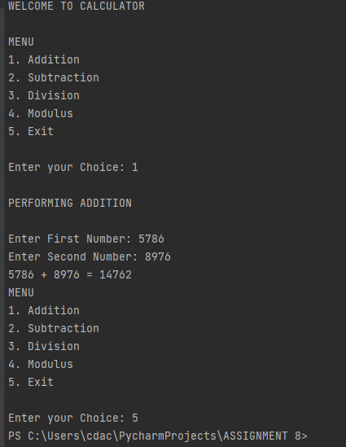

**Q2.** Write simple function definitions and lambda function for:-

1. Finding cube of a number.
2. Finding sqrt. of a number.

Test by taking a no. from user.

**OUTPUT:-**

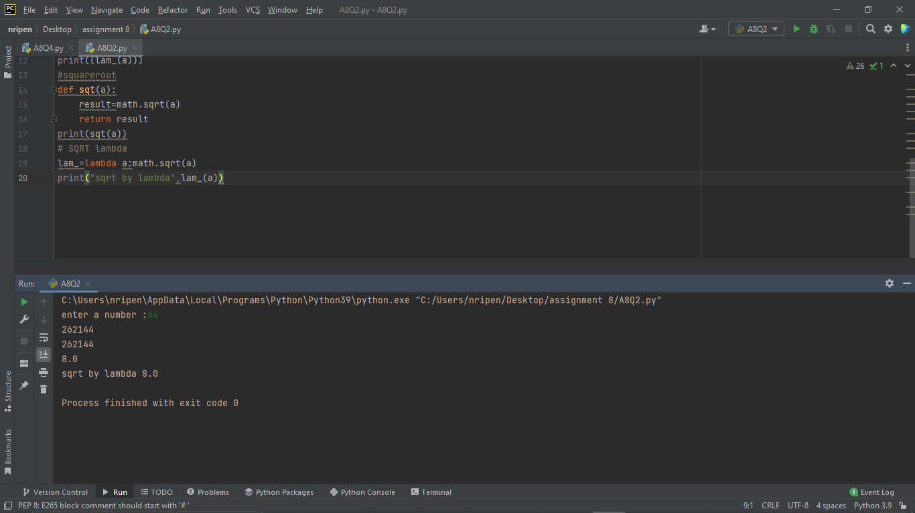

**Q3.** Given a list of numbers , write a code to find the nos. divisible by 7.

**OUTPUT:-**

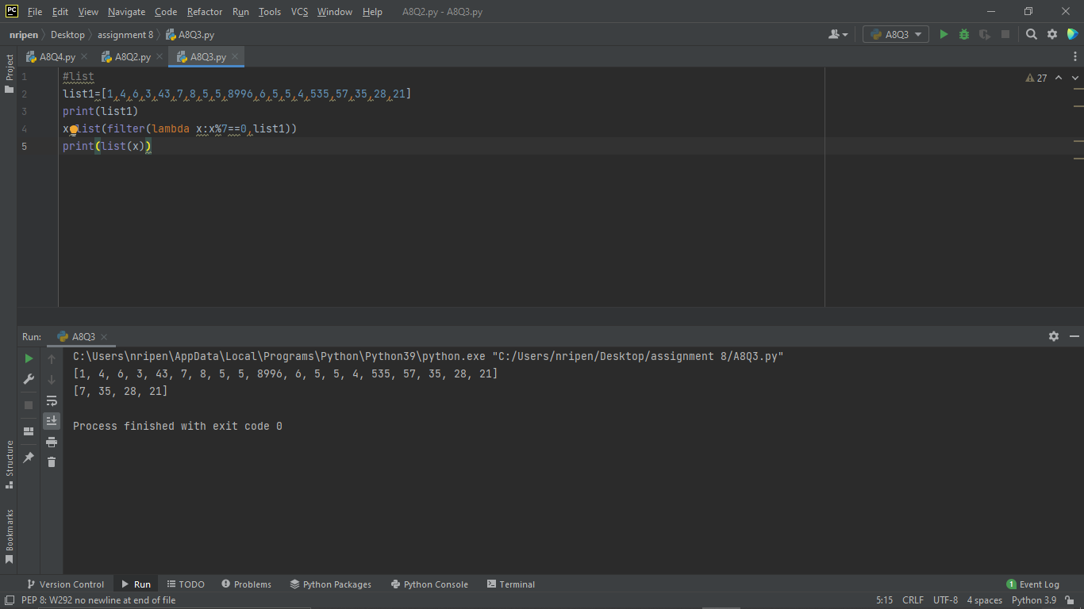

**Q4.** Given a list of alphabets, filter out the vowels present in it.

**OUTPUT:-**

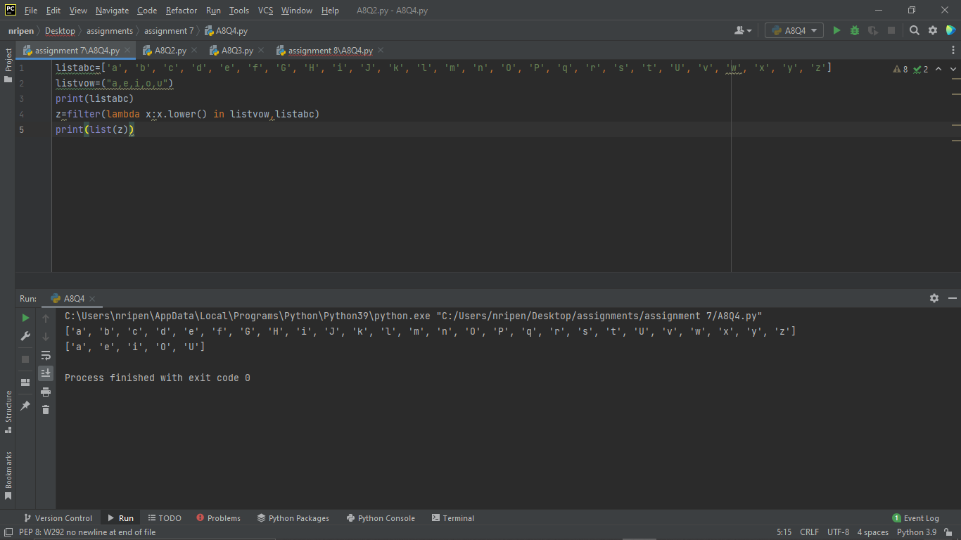

**Q5.** Given a list of fruits

fruits = [‘apple’,’mango’,’banana’]

Transfer this list in new list by converting each fruit name in title case.

**OUTPUT:-**

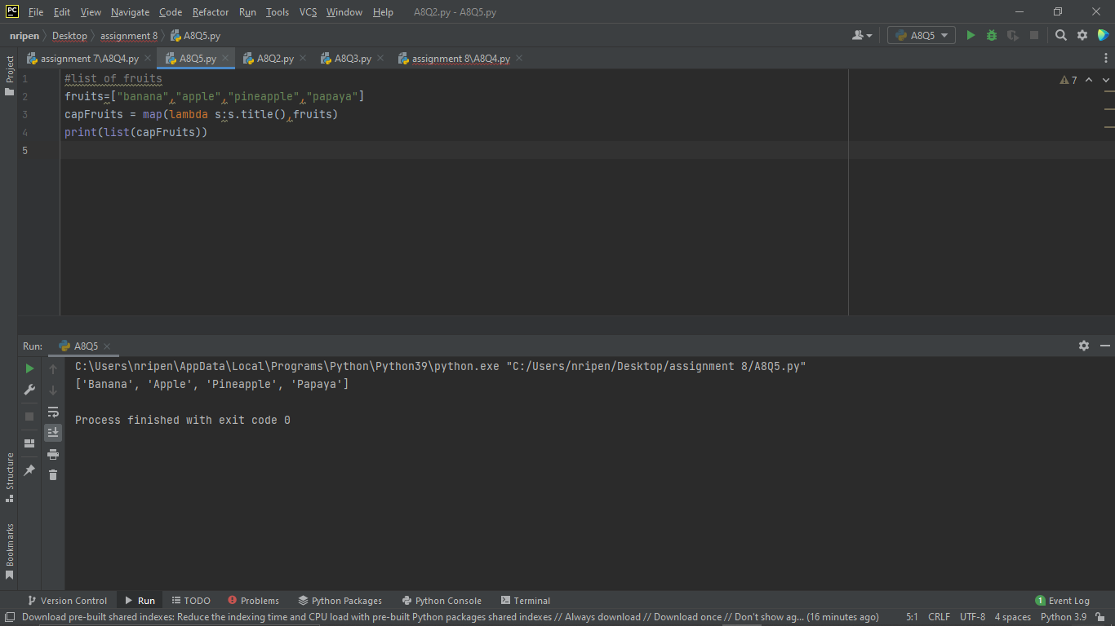

**Q6.** Given a tuple of temperature

temp = (36.5,37,37.5,39)

1. Convert Fahrenheit to Celsius.
2. Convert Celsius to Fahrenheit.

**OUTPUT:-**

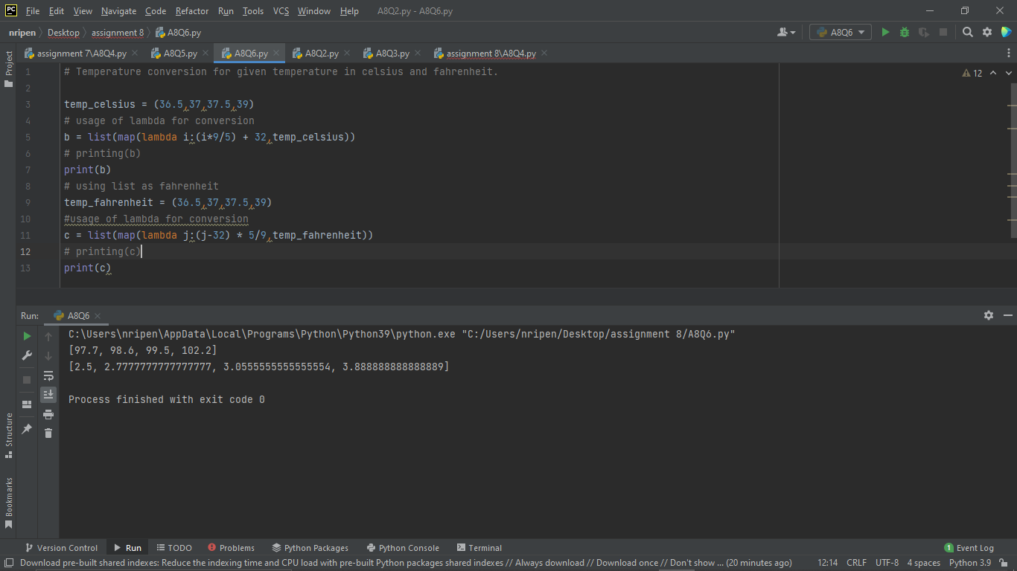

**Q7.** Write a program to demonstrate enumerate function.

**OUTPUT:-**

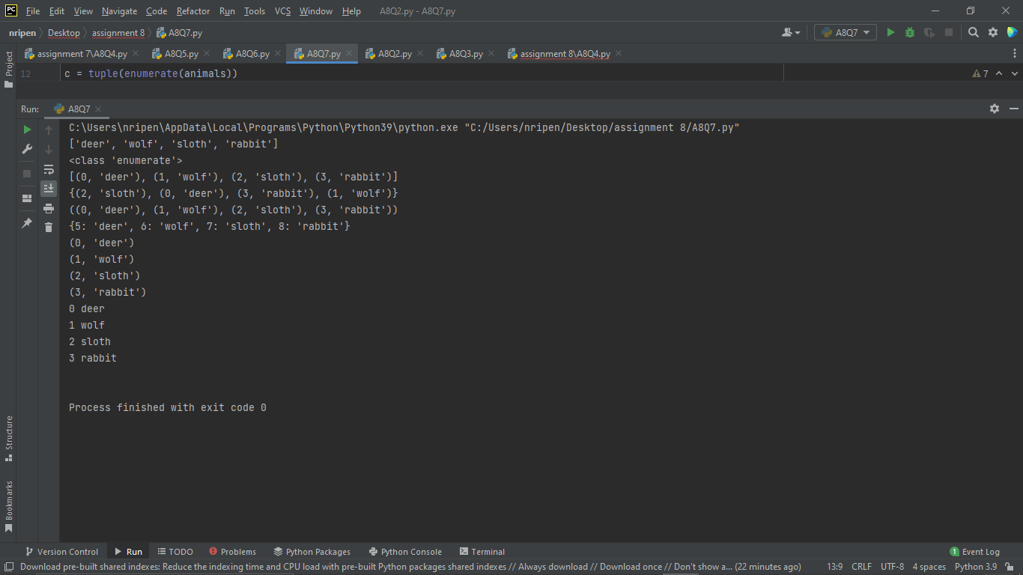

**Q8.** Given a list of strings, filter out the palindromes.

**OUTPUT:-**

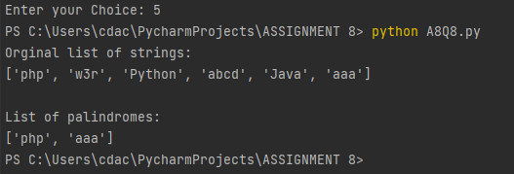

**Q9.** Define functions taking arbitrary arguments. WAS for:-

1. Function to find sum of numbers.
2. Function printing welcome message to names sent as an argument.

**OUTPUT:-**

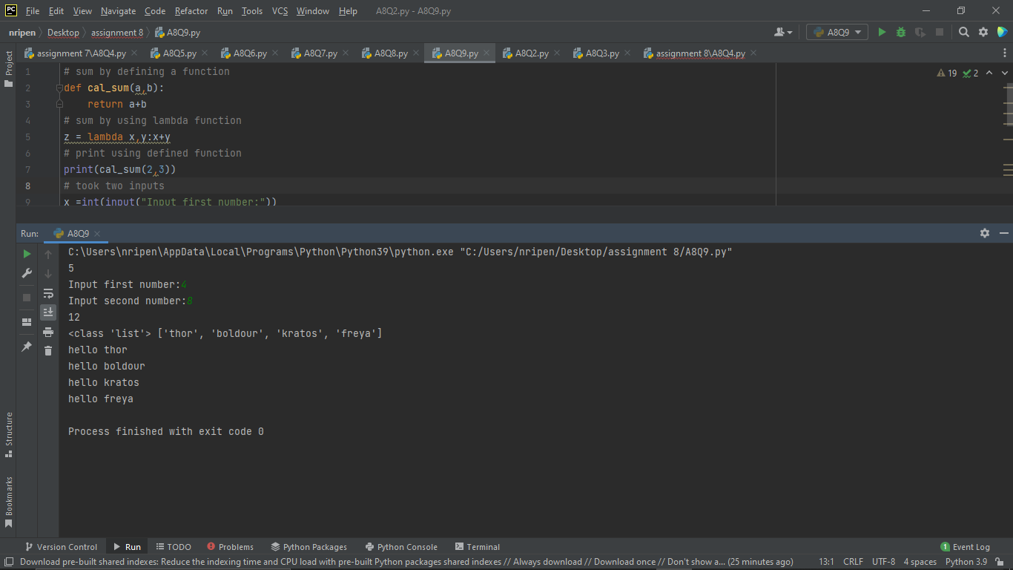

**Q10.** Create a module named ‘CALCULATIONS’. Define following functions with 2 arguments.

1. SUM
2. DIFFERENCE
3. PRODUCT
4. REMAINDER
5. POWER

**OUTPUT:-**

